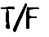
- True or False? Mark each statement as True (T) or False (F). If the statement is false, cross out the wrong part and correct it on the line.

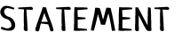

1. People agree about how the government should spend its money.

2. By relying on borrowed money, the
government is at risk if people stop lending.

3. There are negative effects if the government
operates at a surplus.

4. “Balancing the budget” means the government
borrows more money than it spends.

5. People generally believe it’s good for the
government to borrow money.

6. When people lend money, they usually charge
a fee called interest.

7. The government sells IOUs called cupcakes.

8. The government can meet all its spending
needs by collecting taxes.

9. Mandatory spending is spending that Congress
decides on each year.

10. Social Security and Medicare spending are both required by law.

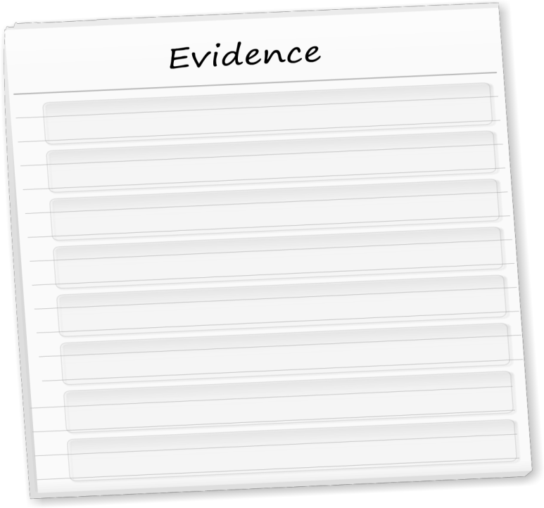
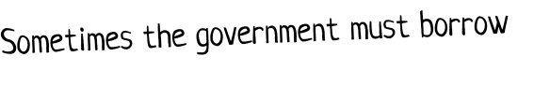
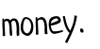
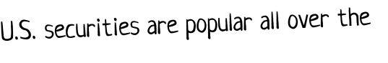
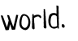
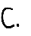
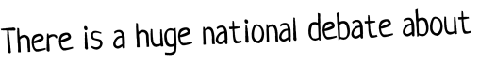
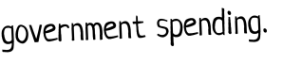
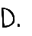
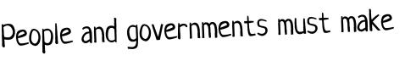
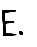
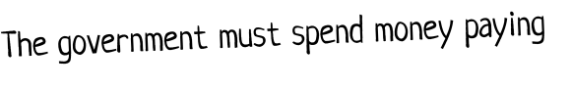
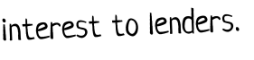
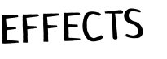
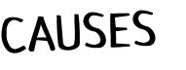
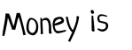
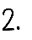
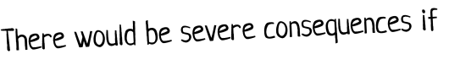
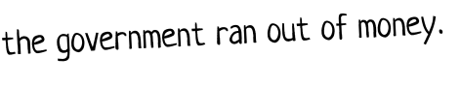
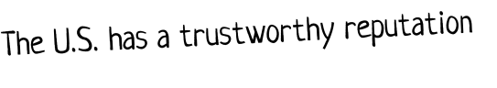
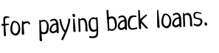
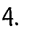
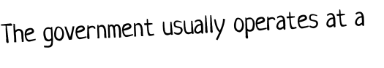
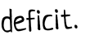
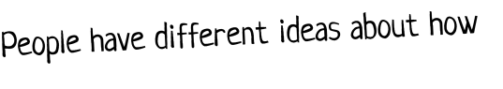
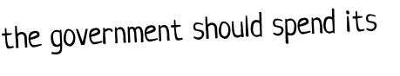
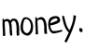
- Cause and Effect. Find the best match for each cause and effect. Be careful: Read them all first!
Worksheet p.1

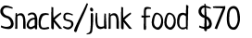
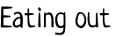
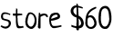
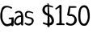
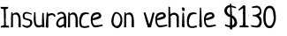
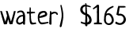
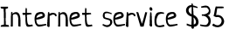
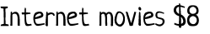
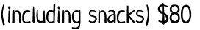
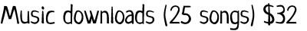
- Trim That Budget! Based on last month’s spending, Sasha needs to trim $500 per month from her budget. Look at Sasha’s budget and decide what she should cut and why.
•
•
•
•
•

•

Budget Item | Amount | Why Can Sasha Cut This?
 | $
 | $
 | $
 | $
 | $
 | $
 | $
TOTAL:

- Not As Simple As It Seems. Things can sometimes seem unnecessary if you don’t have all the information. How would your decisions about Sasha’s budget change if the following were true?

- Sasha is in Big Brothers/Big Sisters, and she meets her little sister for fast food several times
a week. She also takes her elderly uncle to dinner every weekend so he can get out of the house.
What items would you add back, and what would you cut?
- Sasha’s dream is to be a movie critic. She goes to the theater and writes reviews to submit to newspapers. She also watches older movies at home to expand her background knowledge.
What items would you add back, and what would you cut?

