- Log onto: https://libraries.ou.edu
- Click on advanced search

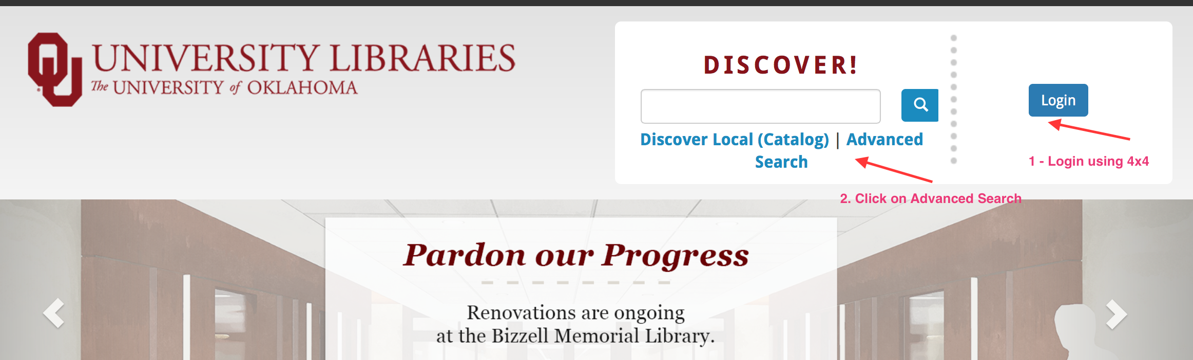

- Enter your search words
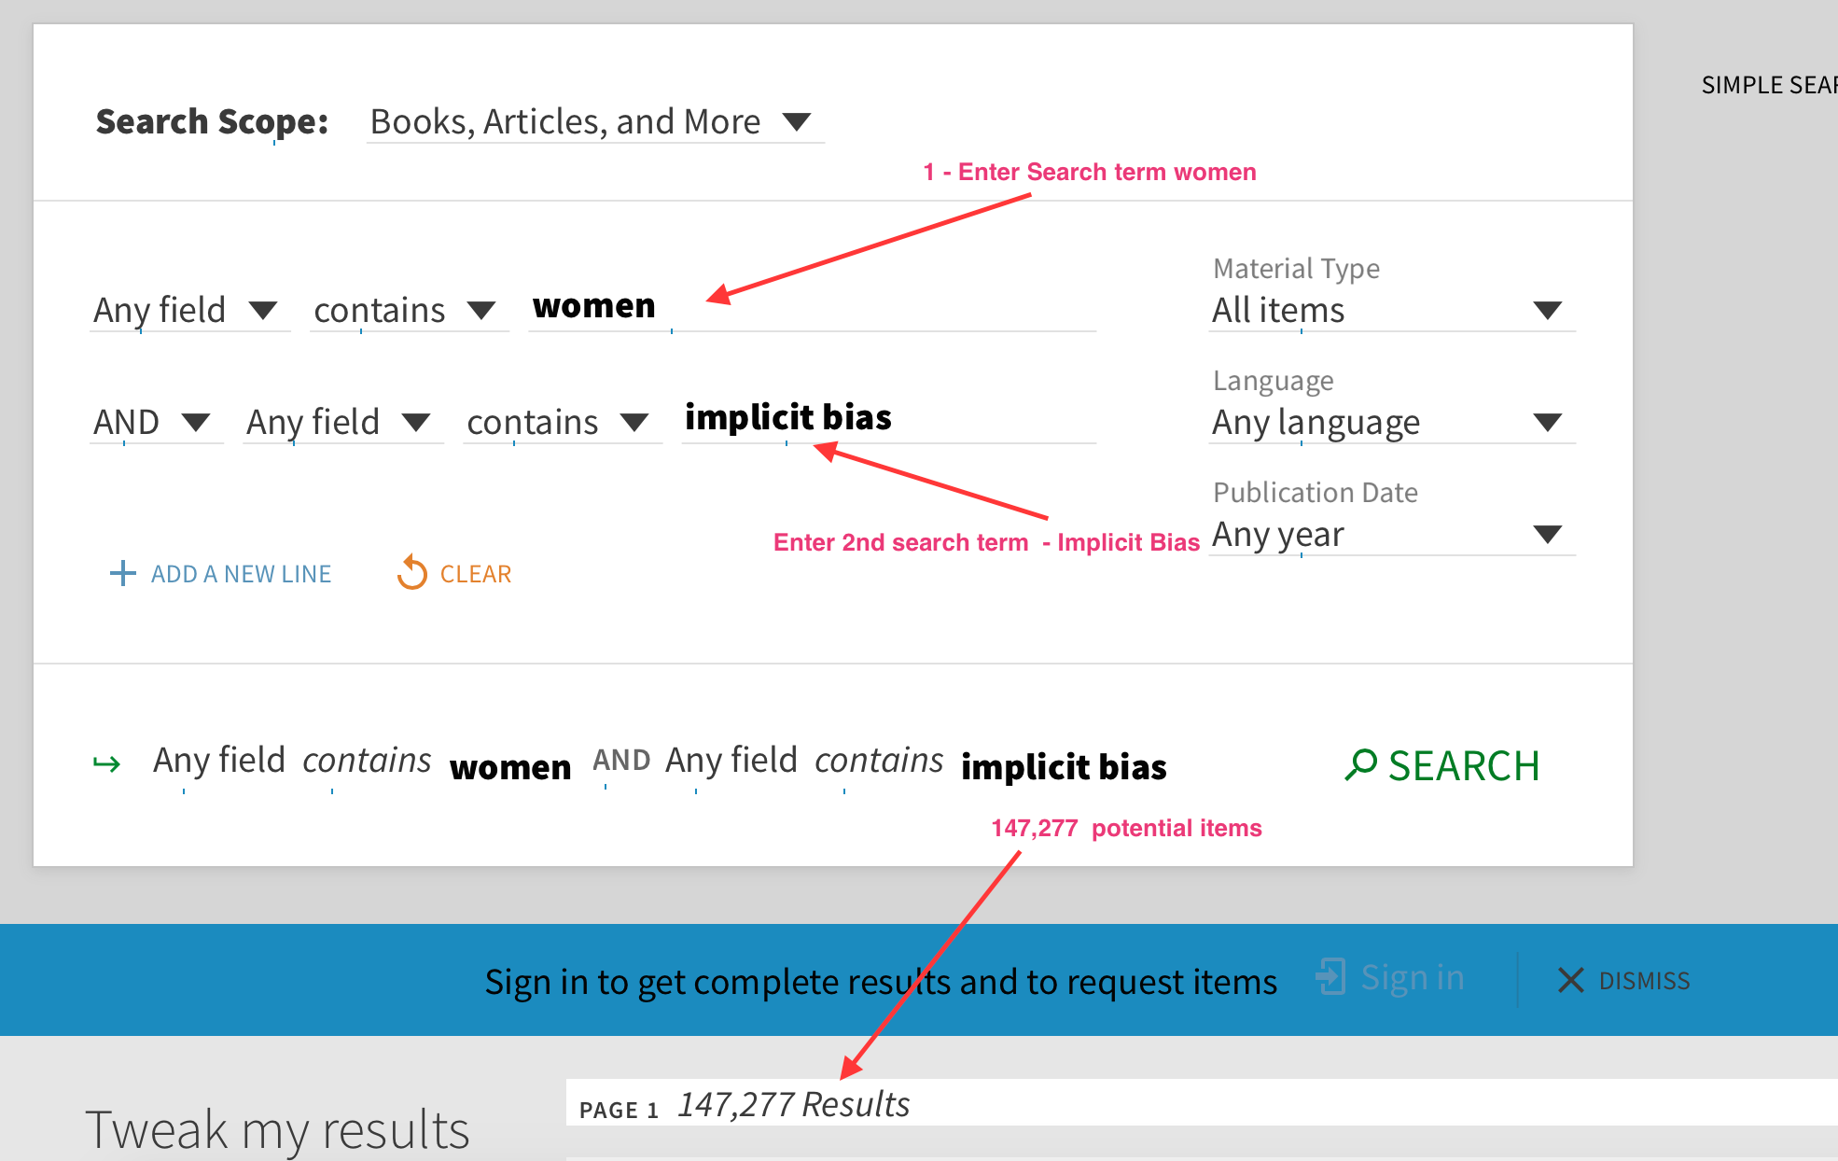
- Make sure you use a variety of words if you are not finding anything - e.g. older adults, aging, elderly are all words in which information may organized.
- The second search term below – implicit bias – could be replaced with strengths perspective, systems theory, ecological theory, etc. for a specific focus

6. If your search yields too many results you can refine it by adding additional search lines and additional search terms. See below
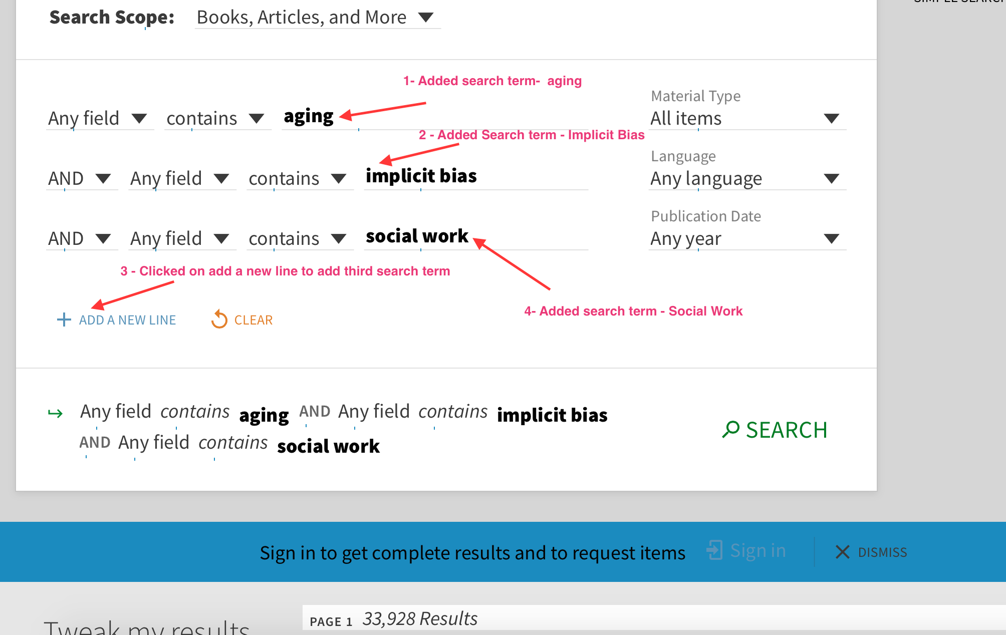

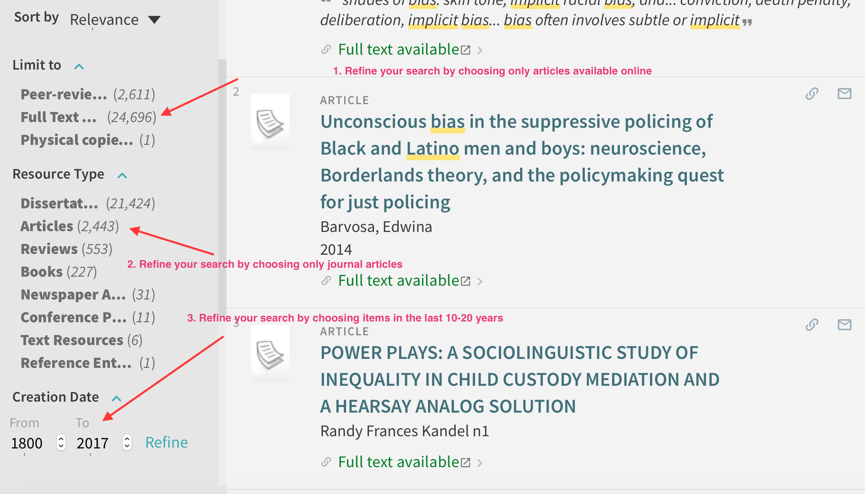
7. Additional ways to refine and limit your search include:

