Students:
Important Changes to the Way You Sign in to Zoom Classes

- When you click on the Zoom meeting link your professor has provided for your class, the Zoom app will now present you with a new screen asking you to authenticate before you can join the meeting. Click the blue Sign in to Join button.
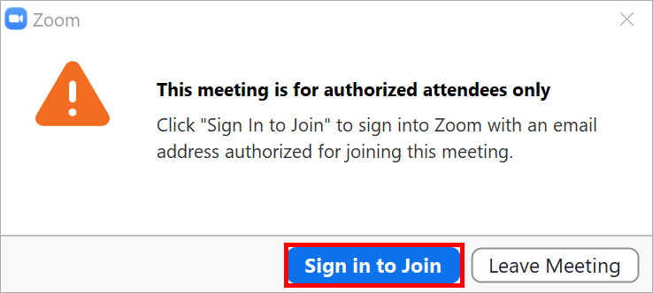
- On the Sign In screen, do not use the email and password fields. Instead, click the Sign in with SSO button located on the right side of the screen.
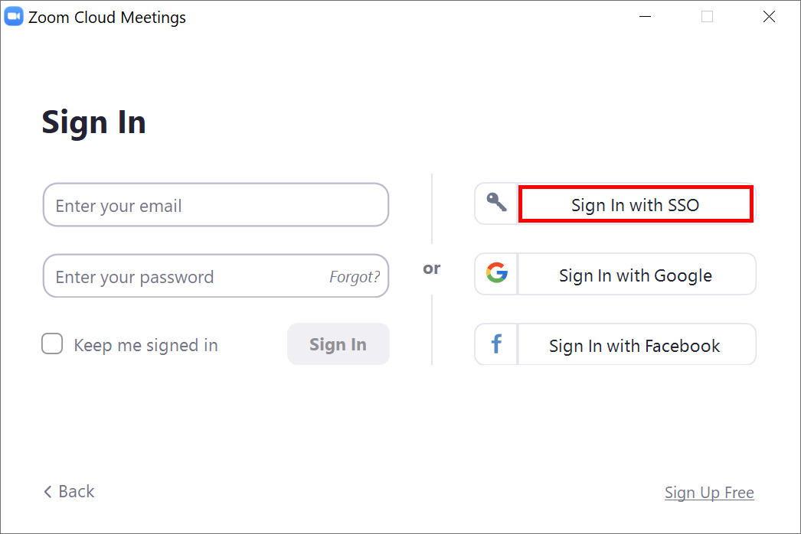

- At the Sign in with SSO screen, type in the word “oklahoma” for the domain (without quotes) and click the blue Continue button.
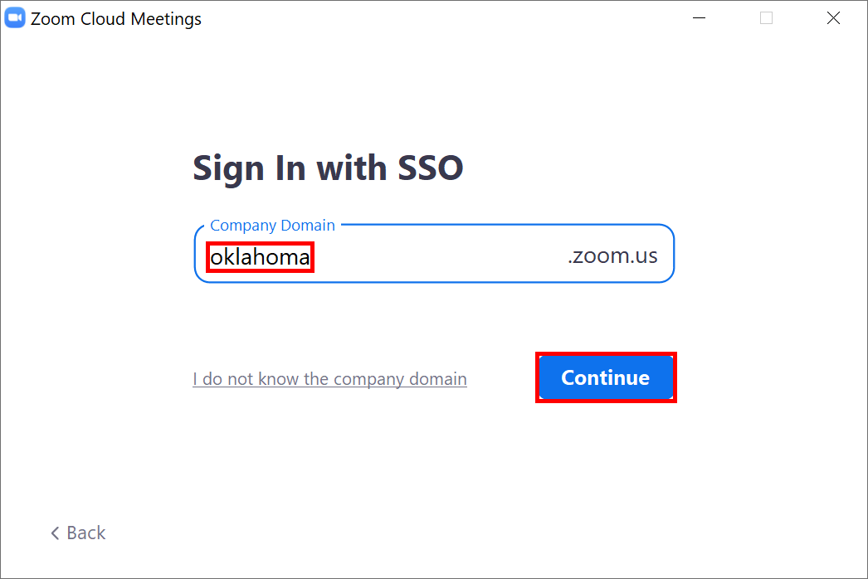
- When presented with the OU logon page, use your OU email address or OUNetID (4x4) for the username, type your OU password, and then click the blue Sign In button. You will now be placed into your Zoom class meeting.
