List of Potential Questions for EMAD 5442 Final Exam
Note 1: This list of potential questions focuses on material covered in class since the midterm. There will be five of these questions assigned for the final exam. The questions will be shown on the final exam in verbatim format from this list.
Note 2: please revisit all slides on Canvas as there were minor updates (corrections of typos) to those as we progressed through the course.
Class #5: Tax
- In class we described the differences between a stock purchase with or without Section 338 election using the following example:
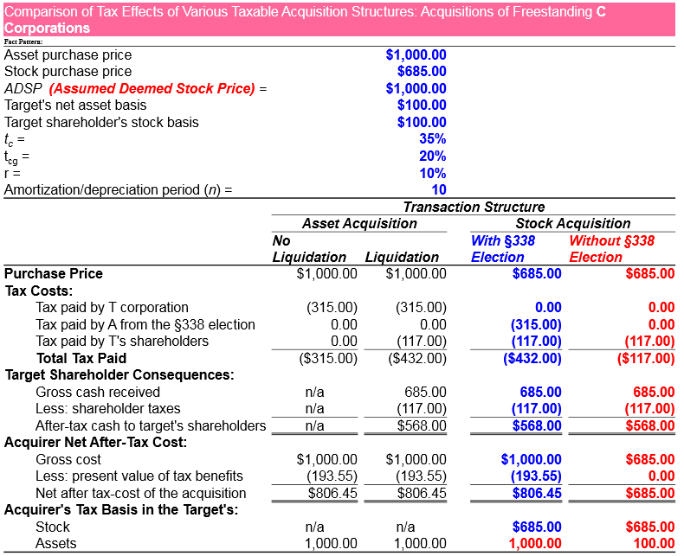
Please discuss the differences between the four presented mechanisms in this chart. Please calculate the ADSP (Aggregate Deemed Sale Price) that is applicable in the case of a §338 election. When would you anticipate that a business chooses to use a §338 election?
(Hint: Please use the discussion to Table 13.2 in the slide set.)

- In class we discussed four tax-free merger structures, presented below:

Using this chart, and the slide notes from class, please describe the main differences between these four mechanisms of tax-free mergers in terms of: (a) net after tax cost to the acquirer; and (b) net after-tax wealth effect to the seller.
(Hint: please use the discussion to Table 16.2 in the slides)
- Can you please compare and contrast the following tax-free acquisition structures in terms of costs and benefits:
  - Merger pursuant to I.R.C. §368 “A”.
  - Triangular merger pursuant to I.R.C. §368 “A”.
  - Merger pursuant to I.R.C. §368 “B”.
  - Merger pursuant to I.R.C. §368 “C”.
  - Merger pursuant to I.R.C. §351.
(Hint: the answer is noted in the slide set.)
- Please describe the differences between: (a) subsidiary stock sale; (b) subsidiary asset sale; (c) spin-off; and (d) equity carve-out.
(Hint: Please use the discussion to Table 13.2 in the slide set.)
Class #5: Accounting
- Please discuss the residual income method for asset value allocations in purchase accounting. What is the treatment of goodwill under SFAS 142? Please discuss in detail. (Hint: the answer is noted in the slide set.)

- What is the tax treatment of asset allocation for the following asset classes, pursuant to FASB 141 and 142 (i.e., purchase accounting):

  - A/R
  - Inventory
  - Real Estate
  - Goodwill
  - Non-compete agreements
  - Consulting/ Employment agreements
  - Intellectual property with legal life
  - Other intangibles
(Hint: the answer is noted in the slide set.)

- How does purchasing accounting reflect a 60% target stock acquisition in terms of the following scenario: buyer has $12m cash & $12m in equity? Target book asset value is $12m, its fair market value is $15m, and the paid price is $20m. Please provide an account of the post-transaction goodwill, total assets, total liabilities, shareholders’ equity, minority interest. (Hint: the answer is noted in the slide set.)

- How does purchasing accounting reflect a 90% target stock acquisition in terms of the following scenario: buyer has $18m cash & $18m in equity. Target book asset value is $12m, its fair market value is $15m, and the paid price is $20m. Using the consolidation method, please provide an account of the post-transaction goodwill, total assets, total liabilities, shareholders’ equity, minority interest. (Hint: the answer is noted in the slide set.)

- Please compare the three methods to account for partial acquisitions of target stock: (1) the consolidation method; (2) the equity method; and (3) the cost method. (Hint: the answer is noted in the slide set.)

Class #6: Bankruptcy
- Please calculate the probability of financial distress if the promised yield on debt (r_{P}) is 10%, the debt beta is 0.10, the market risk premium is 6% and the risk-free rate is 2.5%. Please assume that the recovery rate in default is 50%. (Hint: the answer is noted in the slide set.)

- Please discuss the mechanism of “cram down” in bankruptcy. Please discuss the mechanisms of “automatic stay”, “fraudulent conveyance” and “absolute priority” in bankruptcy. (Hint: the answer is noted in the slide set.)

- What payments are permitted while Chapter 11 is pending? What are the possible post-bankruptcy-petition financing choices (i.e., what kind of debt is permissible during bankruptcy)? Can one-year junior debt can have priority to 10-year senior debt? (Hint: the answer is noted in the slide set.)

- Can insolvency be less costly in a world of high leverage? Please discuss and defend your arguments with examples. (Hint: this argument was discussed in the context of the article by Michael Jensen, “The Eclipse of the Public Corporation” HBR, 1999. Please refer to the slides notes on Canvas to that purpose.)

- Why do firms file for formal bankruptcy? What is the difference between a pre-packaged bankruptcy and a private debt workout? Please explain.
(Hint: the answer is noted in the slide set.)

What is meant by risk-shifting in anticipation of bankruptcy? Please explain using the example from class. (Hint: the answer is noted in the slide set.)

Class #6: M&A Defenses
- Suppose that company A is attempting to acquire company T via unsolicited tender offer. The offer is for a share exchange with exchange ratio of one share of A for each share of T, whereby T has a poison pill plan that is triggered by this hostile takeover attempt. T’s poison pill plan enables each T shareholder, except for the control-seeking one, to obtain a dividend of 2 shares per each share they own at no cost. What will be the effect on the poison pill be, assuming both A and T have each one million shares outstanding?

 | New Company Shares Outstanding |  | Ownership Distribution in New Company (%)
 | Without Pill | With Pill | Without Pill | With Pill
Target Firm Shareholders
Shares Outstanding
Total Shares Outstanding
Acquiring Firm Shareholders
Shares Outstanding
New Shares Issued
Total Shares Outstanding
(Hint: please refer to lecture slide set.)
- Please discuss (1) pro-active takeover defenses; (2) deal-embedded takeover defenses; and (3) reactive takeover defenses. (Hint: please refer to lecture slide set.)

- In class we discussed the example of a poison pill implementation with or without the distribution of dividends, following Professor Robert Bruner’s example in “Poison Pill Dilution Ch.33.xls”, posted on Canvas. Please estimate (in Excel) the raider’s total economic dilution after the pill is triggered if the poison pill “trigger” is alternatively:
  - 5%
  - 10%
  - 15%
  - 20% (hint: this is the baseline scenario shown in the spreadsheet)
Which of the four “trigger” scenarios is the costliest to the raider? Does the anticipated distribution of a dividend cause a change in the raider’s total economic dilution after the pill is triggered? Please explain.
(Hint: please use the Excel spreadsheet “Poison Pill Dilution Ch.33.xlsx” on Canvas.)

Class #7: M&A Contract
- Pleases discuss the MAE/ MAC clauses. How do these clauses work and how frequently were they included in private target acquisitions in 2015? (Hints: the answer is noted in the slide set.)

- Please discuss the following clauses: sandbagging clause, basket clause, and “no-shop/no-talk” clause. How do these clauses work and how frequently were they included in private target acquisitions in 2015? (Hints: the answer is noted in the slide set.)

- Please discuss the following clauses: escrow clause, earnout clause, and cap clause. How do these clauses work and how frequently were they included in private target acquisitions in 2015? (Hints: the answer is noted in the slide set.)
Class #8: M&A Regulation
- Please discuss the anti-trust laws of the Sherman Act (1890), the Clayton Act (1914) and the Celler-Kefauver Act (1950). (Hint: the answer is noted in the slide set.)

- Please discuss the mandate of an acquirer to disclose a merger through the Hart-Scott-Rodino Antitrust Act (1976). (Hint: the answer is noted in the slide set.)

- When can the President of the United States block a merger? Please describe the relevant regulation. (Hint: the answer is noted in the slide set.)

- Please describe the Williams Act. In particular, please discuss the (1) one price rule, (2) the period rule, (3) the conditional acceptance rule, and (all holders rule). (Hint: the answer is noted in the slide set.)

- Please discuss the five-step procedure for U.S. antitrust merger guidelines. (Hint: the answer is noted in the slide set.)

- Please discuss the four main state anti-takeover laws, i.e., please provide a list and a brief description of these laws. (Hint: the answer is noted in the slide set.)

- Please consider the following example:
 |  | Based on Revenues
Company: |  | Revenues | % Market Share | (Market Share)²
#1 |  | 30 | 25.0 | 625.0
#2 |  | 10 | 8.3 | 69.4
#3 |  | 10 | 8.3 | 69.4
#4 |  | 10 | 8.3 | 69.4
#5 |  | 10 | 8.3 | 69.4
#6 |  | 10 | 8.3 | 69.4
#7 |  | 10 | 8.3 | 69.4
#8 |  | 10 | 8.3 | 69.4
#9 |  | 10 | 8.3 | 69.4
#10 |  | 10 | 8.3 | 69.4
Total |  | 120 | 100.0 | 1250.0

Suppose that in a roll-up merger company #1 acquires companies #2. Please calculate the new Hirschman-Herfindahl Index (HHI). Next, suppose that company #1 further announces an acquisition of company #3. Will that be allowed by the FTC and The Department of Justice? Please show your work. (Hint: please follow the method presented in Excel file “HHI Example.xls” to solve this question.)

