How to download KNIME Analytics Platform

- Go to the download page to start downloading KNIME Analytics Platform.
Link: https://www.knime.com/downloads

- The download page shows three tabs which can be opened individually. Open the Download KNIME tab and click the installation option that fits your operating system.
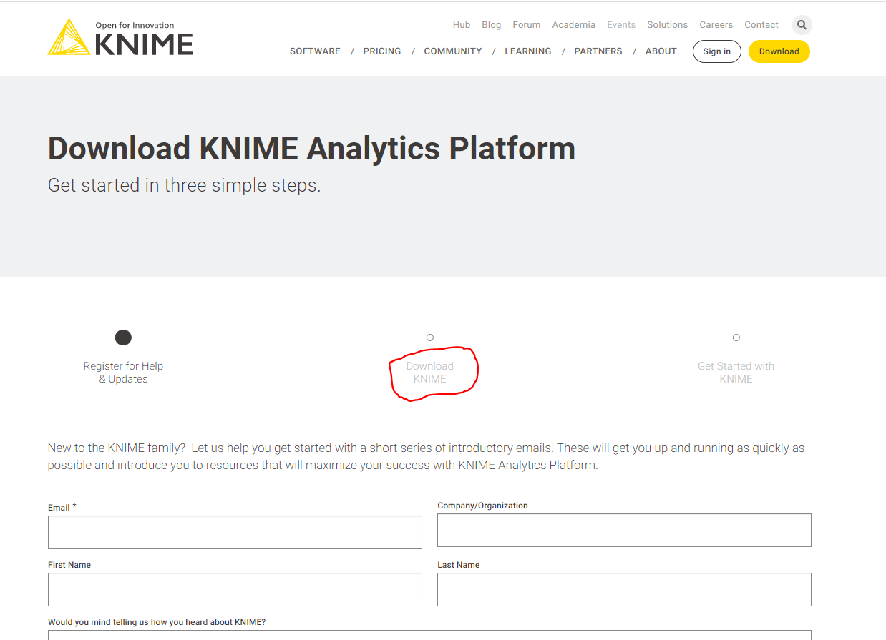

- For Windows users, click in Download for the KNIME Analytics Platform for Windows (installer) option
- For Mac users, click in Download for the KNIME Analytics Platform for macOS (10.13 and above) option.
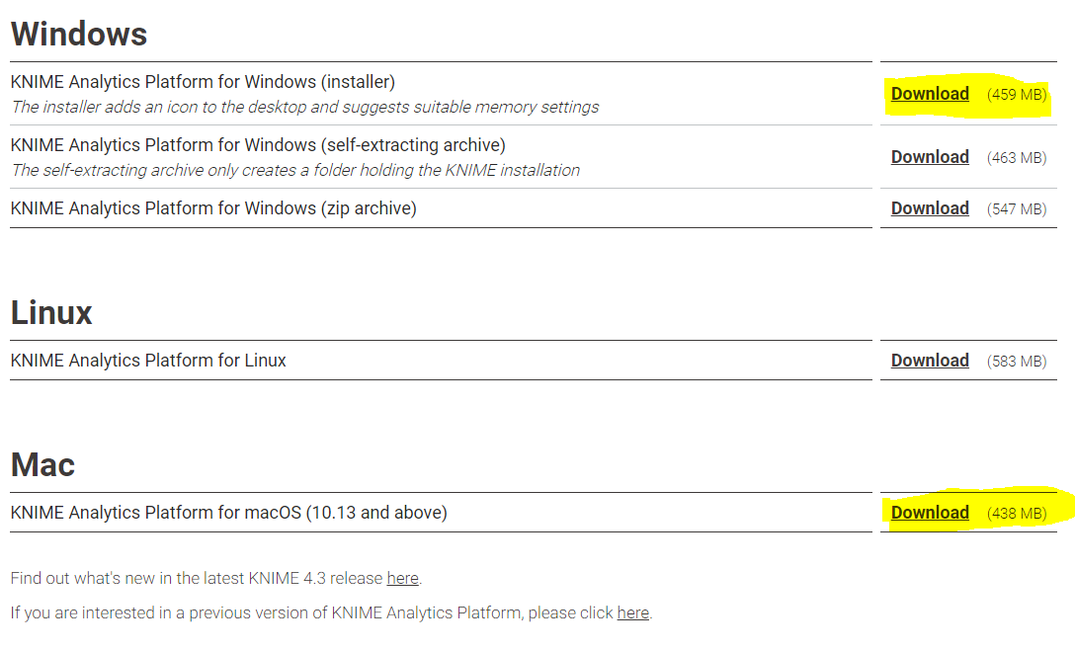
- Accept the privacy policy and terms and conditions. Then click Download.
- Follow your PC installation setup steps. You may select the default option given by KNIME during the set up.

