How to Work the Waitlist.

When you search for a course and the class is full with a waitlist.

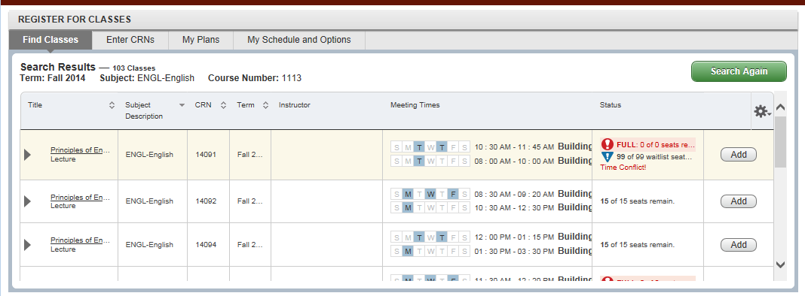
Add button will still be active.
Class will show Full and having Waitlist.

Once you click on the Add button, it will place the course in your Summary view as pending. (Notice that a course that is pending is shaded in the Summary View.) You will need to change the status from “Self-Service Enrollment” to “Waitlist” and then submit your request.

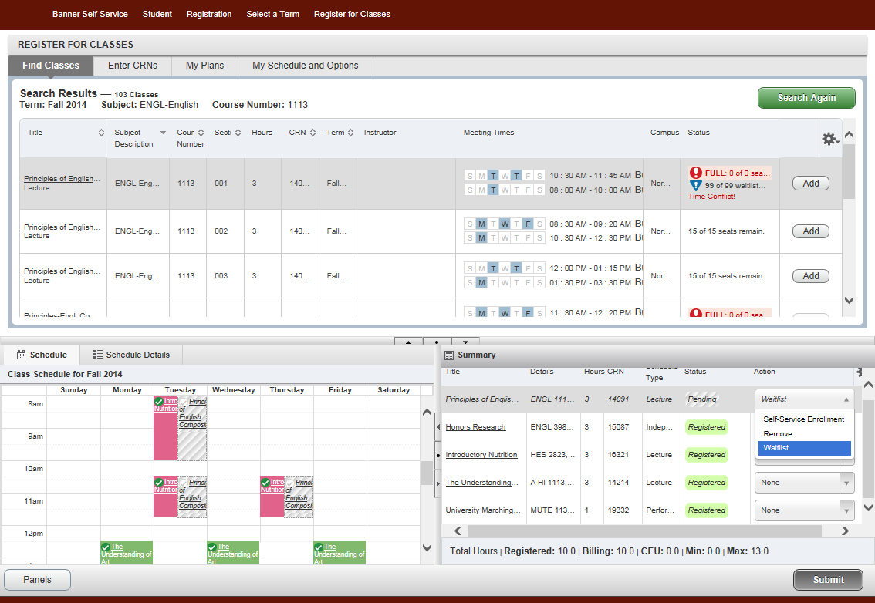
Use the drop down box to select Waitlist.

Once you have submitted the request, you will receive a message that shows that you have successfully saved the transaction. You will notice that there is a green square in the status column.

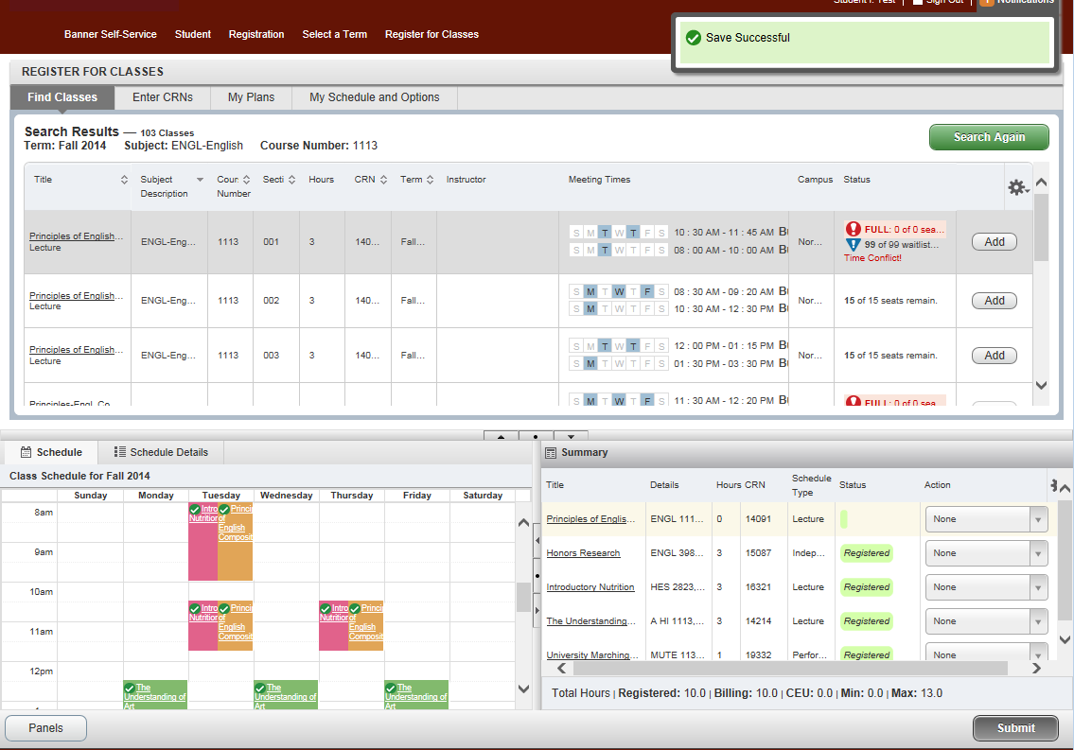

Once a seat in the course opens up, you will receive an email informing you that you can now enroll in the course. Copy of E-mail displayed below. NOTICE – You will have only 24 hours to add the course before you are dropped off the waitlist. This E-mail will only be sent to your OU email address.
Wording of E-mail

A seat has become available in the waitlisted CRN in the subject line. You have 24 hours to enroll. If you do
not enroll yourself in the course within the 24 hours and are still interested in the course you will need to add
yourself back to the waitlist. If you are not interested in enrolling in a course for which you are waitlisted, please
drop yourself from the waitlist for the course.
Enrollment Services

Log in to Ozone and go to your schedule. In your Summary view, change the Action to “Self-Service Enrollment”. You will need to take care of any error messages before submitting.

